Ref. No: Date: 04.01.2024

Notice Regarding 1st Semester Major Internal Exam
It is hereby notify to all 1st semester major students that an internal examination will be held as per schedule below from 10:45 am everyday in room no 205. All students must attain positively within stipulated time. No excuse will be entertained. If anyone will fail to appear in the exam in stipulated time he/she will be treated as an absent candidate.
DATE | PAPER CODE
15/01/2024 | CHEM-SEC-1
16/01/2024 | CHEM-MAT-1 (Physical-1A)
18/01/2024 | CHEM-MAT-1 (Inorganic-1A)

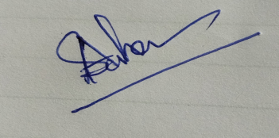
HOD
Department of Chemistry

